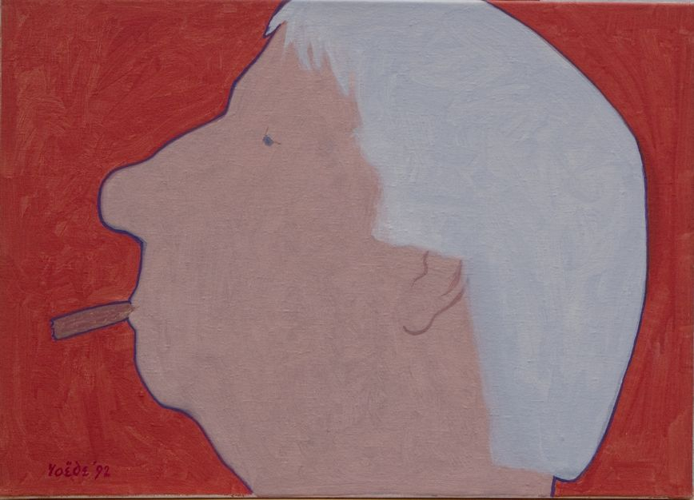

JURY REPORT JAN ROEDE PRIZE 2020

On 13 June 2014 it was 100 years ago that the Hague visual artist Jan Roëde (1914-2007) was born. On this occasion, the board of the Jan Roëde Foundation, the foundation that manages his artistic legacy, in collaboration with the management of the Royal Academy of Art, decided that year to establish the Jan Roëde Prize, an annual incentive prize for a graduating artist from the Department of Visual Arts of the KABK.
As a token of recognition, the prize is intended to stimulate the winner to further develop his or her talents.
The jury for the Jan Roëde Prize 2020 consisted of Louw van Sinderen, Dick Stapel, Huub van Wersch (all members of the Foundation Board) and John Sillevis (former chief curator of the Gemeentemuseum The Hague). The jury was guided by KABK teacher and visual artist Pim Voorneman.
On 9 September 2020 the jury judged the works and presentations of the students of the Fine Arts department who graduated from the KABK this year. The jury was impressed by the quality, diversity and eloquence of many of the projects shown during the exhibition. The artist unanimously chosen by the jury to receive the Jan Roëde Prize 2020 is:
Erlend Evensen

Erlend Evensen has completely shaped the space available to him by painting not only the four walls, but also the floor and ceiling with an intriguing entity of flowing black and white drawings. When the visitor - after taking off his shoes or wrapping them - enters this space, he imagines himself in a different dimension. The restriction which Evensen has imposed on himself by not using color in the articulation of his forms works extremely effectively. The colorful multitude which usually surrounds us is playfully and rhythmically transformed into stylized forms. The presence of all these artistic images around us cannot be enjoyed at the same time, because of the limitations which are inherent to the human gaze, but only by scanning the space horizontally, vertically and diagonally with the eye. In this way, the static omnipresence of the artwork unrolls as a dynamic succession of images and the viewer becomes part of a cinematic event that takes place in silence. Are we experiencing what is going on in the artist's inner world of thought and imagination? Or does Evensen, by weaving together the two-dimensionality of his drawings in the three dimensions of the space, invite us to look and experience in a different way? Although the fascinating interplay of lines encapsulates us as it were, we mainly experience space that extends to invisible endings.
Evensen has, like a true magister, applied his black and white paintings with a master's hand. In a zebra-like unity of style they show a wide variety of abstract and figurative images that seem to produce and carry each other and that offer openings on all sides to illusory depths and distractions. Evens makes ingenious use of visual quotations, such as the procession of zebras that refers to Muybridge's galloping horses from the early days of cinema.
With his presentation "Prima Materia" Erlend Evensen convinced the jury of his talent, his guts and his craftsmanship. It is our great pleasure to declare him the winner of the Jan Roëde Prize 2020.
On behalf of the jury of the Jan Roëde Prize,

Huub van Wersch,
Chairman of the jury

The Hague, 13 September 2020

The Jan Roëde Prize 2020 consists of a sum of €2500 that the receiving artist is free to spend. The Jan Roëde Foundation will - in consultation with the prizewinner - pay attention on its website (www.janroede.nl) to the award ceremony and to the artist who has won the prize.

Jan Roëde Stichting p/a Benoordenhoutseweg 262 2596 BJ Den Haag tel. 06-11067914 www.janroede.nl info@janroede.nl

