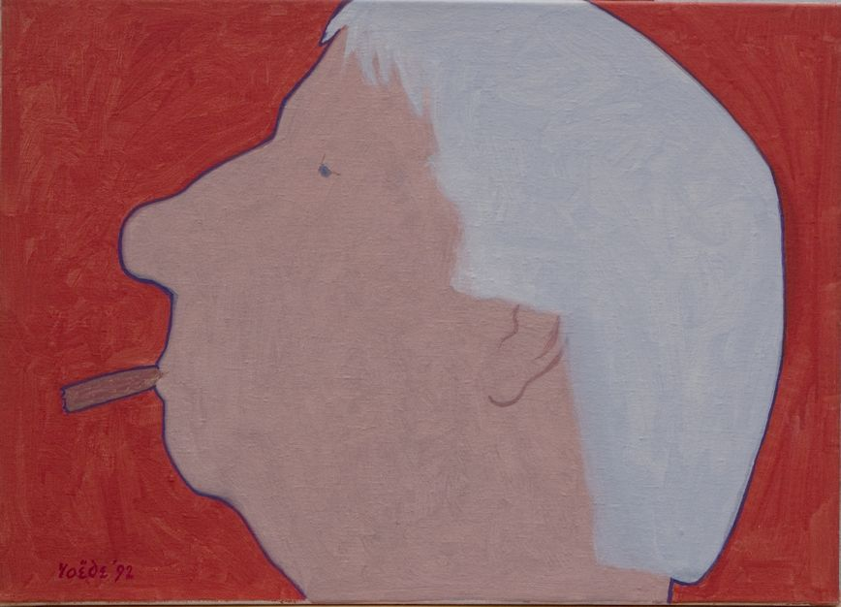

JURY REPORT JAN ROEDE PRIZE 2020
Certificate of Excellence – Isa van Lier

On 13 June 2014 it was 100 years ago that the Hague visual artist Jan Roëde (1914-2007) was born. On this occasion, the board of the Jan Roëde Foundation, the foundation that manages his artistic legacy, in collaboration with the management of the Royal Academy of Art, decided that year to establish the Jan Roëde Prize, an annual incentive prize for a graduating artist from the Department of Visual Arts of the KABK.
As a token of recognition, the prize is intended to stimulate the winner to further develop his or her talents.
The jury for the Jan Roëde Prize 2020 consisted of Louw van Sinderen, Dick Stapel, Huub van Wersch (all members of the Foundation Board) and John Sillevis (former chief curator of the Gemeentemuseum The Hague). The jury was guided by KABK teacher and visual artist Pim Voorneman.

Isa van Lier
She receives the "Certificate of Excellence" for her installation "ZEN SUPERMARKET". In this installation, Isa van Lier has brought together colorful paintings and ceramic figurines that testify to her fascination with Zen Buddhism. Shot from an uninhibited frame of mind is a playful, colourful entity that is also restrained. If there was one presentation of the works exhibited at the Graduation Show in which the jury found the spirit of Jan Roëde – name giver of the prize - it was this overwhelming collection of intuitive forms, colors and images.
In addition to the Certificate of Excellence, the artist receives a sum of €1000 which she is free to spend.

Huub van Wersch,
Chairman of the jury

The Hague, 13 September 2020

Jan Roëde Stichting p/a Benoordenhoutseweg 262 2596 BJ Den Haag tel. 06-11067914 www.janroede.nl info@janroede.nl

