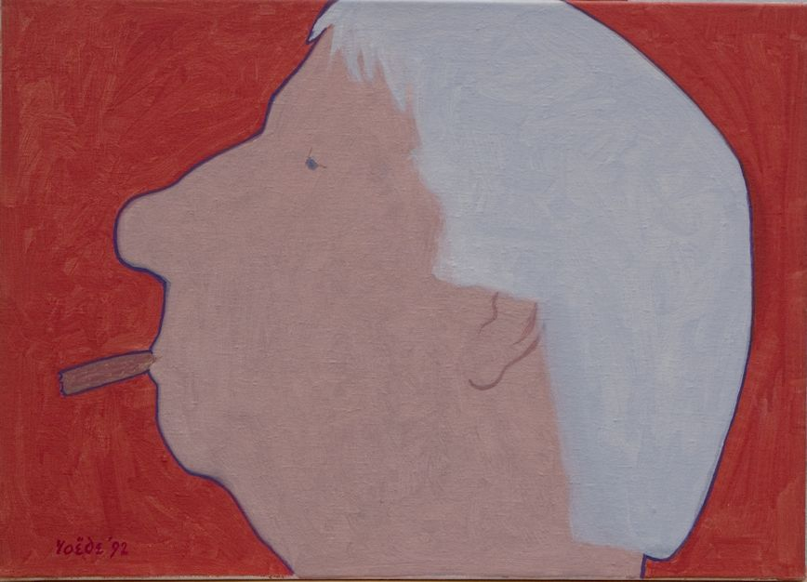

JURY REPORT JAN ROEDE PRIZE 2020
Certificate of Excellence – Danny Choi

On 13 June 2014 it was 100 years ago that the Hague visual artist Jan Roëde (1914-2007) was born. On this occasion, the board of the Jan Roëde Foundation, the foundation that manages his artistic legacy, in collaboration with the management of the Royal Academy of Art, decided that year to establish the Jan Roëde Prize, an annual incentive prize for a graduating artist from the Department of Fine Arts of the KABK.
As a token of recognition, the prize is intended to stimulate the winner to further develop his or her talents.
The jury for the Jan Roëde Prize 2020 consisted of Louw van Sinderen, Dick Stapel, Huub van Wersch (all members of the Foundation Board) and John Sillevis (former chief curator of the Gemeentemuseum The Hague). The jury was guided by KABK teacher and visual artist Pim Voorneman.

Danny Choi
He receives the "Certificate of Excellence" for his video presentation "IS BUSY". With "IS BUSY" Danny Choi has created a video installation that pulses to the rhythm of penetrating beats, showing a fascinating sequence of images and texts in which contemporary and deep-personal questions of life bubble up. The perfect interplay of sound and images, reflected in a large puddle of water underneath the projection screen, continues to fascinate from start to finish and bears witness to great artistic craftsmanship.
In addition to the Certificate of Excellence, the artist will receive a sum of €1000 which he is free to spend.
Huub van Wersch,
Chairman of the jury

The Hague, 13 September 2020

Jan Roëde Stichting p/a Benoordenhoutseweg 262 2596 BJ Den Haag tel. 06-11067914 www.janroede.nl info@janroede.nl

